# CHAPTER THREE

# SYSTEM DESIGN AND ANALYSIS

## 3.1 Introduction

This chapter contains the system design, the disadvantages of the existing system, the advantages of the proposed system over the existing system, the system requirements (Hardware and Software), the design and the system architecture.

## 3.2 Disadvantages of the Existing System

1. Limited Visibility: The current portfolio might not be reaching its full potential audience due to limited visibility. If it's not optimized for search engines (SEO), it may not appear in relevant search results.
2. Static and Outdated: Traditional portfolios are often static and do not adapt to changing trends or technologies. They may quickly become outdated, failing to showcase the latest skills and projects.
3. Limited Interactivity: Existing portfolios may lack interactivity, making it challenging to engage and impress visitors effectively. Interactivity can enhance user experience and leave a lasting impression.
4. Inconsistent Presentation: Different projects and skills may be presented inconsistently in terms of layout, design, and content, making it harder for viewers to navigate and understand the portfolio's content.
5. Lack of Analytics: Without analytics, it's difficult to track user engagement and assess the portfolio's effectiveness. You may not have insights into which projects or skills are most appealing to visitors.

## 3.3 Advantages of the Proposed System

1. Enhanced Interactivity: The proposed interactive portfolio will engage visitors through dynamic elements, such as animations, clickable elements, and interactive project showcases, creating a memorable user experience.
2. Real-time Updates: Unlike static portfolios, the new system will allow for easy and real-time updates. You can quickly add new projects, update skills, and keep the portfolio fresh and relevant.
3. Improved SEO: The proposed system will be optimized for search engines, increasing the portfolio's visibility and making it more likely to appear in relevant search results.
4. Consistent Presentation: The portfolio will maintain a consistent and professional presentation style across all projects and skills, improving overall usability and aesthetics.
5. Analytics and Insights: By integrating analytics tools, you'll gain valuable insights into user behavior. You can track which projects attract the most attention, how visitors navigate your portfolio, and use this data for continuous improvement.
6. User Engagement: The proposed system will include features like contact forms, comment sections, or interactive elements that encourage user engagement, making it easier for potential clients or employers to connect with you.

## 3.4 The Proposed Method

The waterfall model is a traditional sequential approach to software development that consists of distinct phases that follow a linear sequence. Here is a simplified version of the waterfall model for the development of an Interactive Portfolio Website Showcasing Skills and Projects.

**Requirements Gathering and Analysis:**

1. Identify the requirements and objectives of the Interactive Portfolio Website Showcasing Skills and Projects.
2. Conduct interviews and discussions with stakeholders to understand their needs.
3. Define the system's functionalities, user roles, and security requirements.

**System Design:**

1. Design the system architecture, including the client-side and server-side components.
2. Create the database schema and define the data model.
3. Develop the user interface design, considering usability and accessibility.

**Implementation:**

1. Develop the client-side application using web technologies like HTML, CSS, and JavaScript.
2. Implement the server-side application using a suitable programming language and framework.
3. Integrate the user interface with the backend functionalities.
4. Implement security measures such as encryption, authentication protocols, and access control.

**Testing:**

1. Conduct unit testing to verify the correctness of individual components.
2. Perform integration testing to ensure the proper functioning of the system as a whole.
3. Carry out system testing to validate the system against the defined requirements.
4. Perform security testing to identify and address any vulnerabilities.

**Deployment:**

1. Prepare the system for deployment by configuring the necessary infrastructure and servers.
2. Install and set up the required software and dependencies.
3. Migrate the database and ensure data integrity.
4. Conduct user acceptance testing to gain feedback and ensure readiness for production use.

**Maintenance and Support:**

1. Provide ongoing maintenance and support for the Interactive Portfolio Website Showcasing Skills and Projects.
2. Address any reported issues, bugs, or security vulnerabilities.
3. Perform regular system updates and enhancements based on user feedback and changing requirements.
4. Ensure the system remains secure, reliable, and up-to-date.

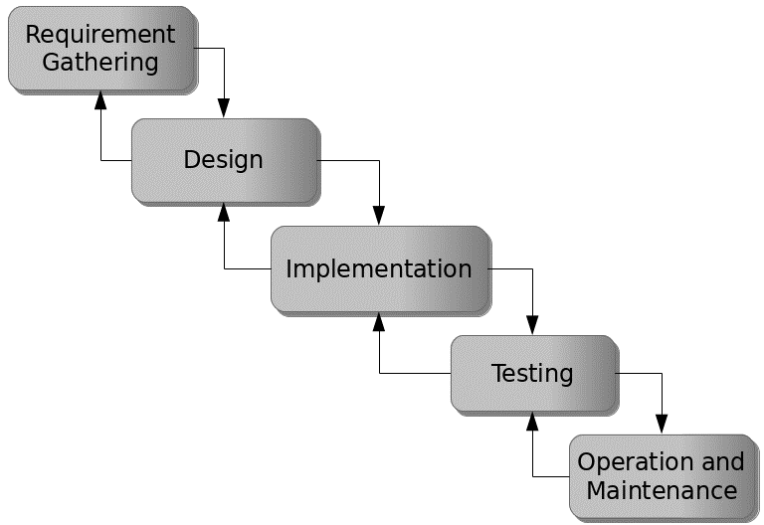

Figure 3.1: Waterfall model

## 3.5 Method of Data Collection

This study will adopt two methods of data collection:

**Primary Source:** Primary source refers to the sources of collecting original data in which the researcher makes use of empirical approach such as personal interview, questionnaires or observation.

**Secondary Source:** The need for the secondary sources of data for this kind of project cannot be over emphasized. The secondary data were obtained from magazines, Journal, newspapers, library source and most of the information from the library research has been covered in the literature review section.

## 3.6 System Design

Systems design is the process of defining the architecture, modules, interfaces, and data for a system to satisfy specified requirements. Systems design could be seen as the application of systems theory to product development.

## 3.6.1 Algorithm Diagram

**Use case diagram**

A use case diagram at its simplest is a representation of a user’s interaction with the system and depicting the specifications of a use case. A use case diagram shows the system and the various ways that they interact with the system.

**INTERACTIVE PORTFOLIO WEBSITE**

Start

View Skills

Send Message

View Projects

User

Get in touch

Stop

Figure 3.2: Use Case Diagram

**3.6.2 System Architecture**



Database MySQL

Apache Server

Interactive Website

Figure 3.3: System Architecture

## 3.6.3 Input and Output Design

**GET IN TOUCH**

Email

Name

Message

**SEND**

Figure 3.4: Get In touch form

**PROJECTS**

First Name

First Name

First Name

First Name

First Name

First Name

Figure 3.5: Projects Interface

## 

## 3.4 System Requirement Specification

## 3.4.1 Hardware Requirements

The software to be design needs the following hardware for an effective operation of the newly designed system.

1. A system running on intel, P(R) duo core with higher processor
2. The-Random Access Memory (RAM) should be at least 512MB.
3. At least 20-GB hard disk.
4. A monitor.

## 3.4.2 Software Requirements

The software requirements include:

1. A window 7 or higher version of operating system.
2. XAMP or WAMP for Database
3. PHP
4. MySQL
5. Browser

## 3.4.3 Personnel Requirements

Any computer literate who has a technical knowhow of internet surfing can use the system because it is user friendly.